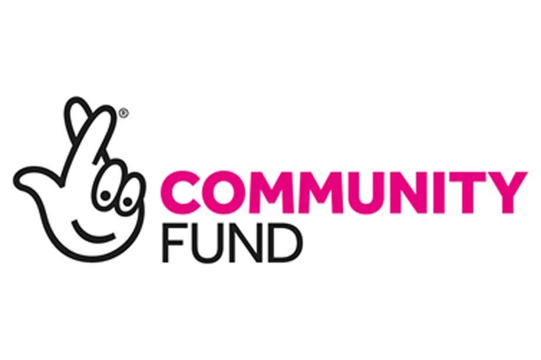Sensing Friends are recruiting

- Funded by The Big Lottery, Sensing Friends runs a counselling service for young people between 8 -25 years who experience sensory needs.

- The counselling service offers short-term counselling of up to 16 weeks, either remotely or face to face.

- The counselling service offers online peer support and group therapy sessions facilitated by at least two counsellors per session.

- Hourly rate £25.00

We are currently seeking to recruit
- Qualified children and young people counsellors with a minimum of 2 years post qualified experience.
- Counsellors who have experience using solution focused methods, focusing on emotional supportive strategies such as safety and stabilisation techniques.
- Counsellors who can offer at least 2 sessions per week
- Counsellors who are registered with a counselling professional body i.e. BACP or other recognised professional body, or willing to register.

We are particularly interested in hearing from counsellors who have

- Experience of working with young people who are dealing with issues related to either physical sensory needs, such as a visual/ hearing impairment, neurological sensory needs such as Autism or psychological sensory needs such as Post Traumatic Stress Disorder.

- Lived experience of the sensory needs mentioned above.

What we duties we will require in this Counselling post

- Counsellors will be required to offer at least 1 1 to 1 counselling session per week and upto a maximum of 4 per week, for young people with sensory needs, either online or face to face where appropriate.
- Counsellors will be required to help in setting up and facilitating weekly online group therapy and peer support sessions as well as some monthly face to face sessions where appropriate.

Please see further details below.

Sensing Friends is a charity providing eco-therapy peer support groups for young people experiencing sensory needs who are vulnerable to isolation, low self esteem and social exclusion. We are a unique organisation that works within nature in a creative and engaging way to help young people connect with each other and themselves. We define a sensory need broadly. A sensory need can be physical, such as visual or hearing impairment. It can also be neurological, such as sensory experiences related to Autism and/or psychological, such as sensory experiences caused by trauma and PTSD.

We have an egalitarian code of practice that we hope is empowering for all who engage within Sensing Friends. Our code of practice upholds transparency and inclusion for all, at all times.

What we will offer
- We will offer between 2- 6 paid counselling work sessions per week
- We offer regular one to one support to our team of counsellors as and when needed.
- CPD support
- We offer free monthly group supervision sessions for the Sensing Friends counselling work
- Room rental costs of running the Sensing Friends face to face sessions where appropriate
- Travel expenses

What we require from Sensing Friends Freelance Counsellors
- Have regular supervision with their own supervisor or attend Sensing Friends group supervision.
- Have up to date counselling insurance, including professional liability insurance.
- Current up to date enhanced DBS check or willing to be DBS checked.
- 2 current references with at least one work related to your previous or current counselling with young people .

Application and Interview Process

- Please contact us below for an application pack. The pack contains an application form which needs to be completed and returned by the closing date.
- Where appropriate and If you have been advised that you can apply via expression of interest please contact us to ask for an expression of interest pack. The pack contains an expression of interest form which needs to be completed and returned by the closing date.

- Candidates will be interviewed by a designated counsellor/ counsellors from Sensing Friends counselling team
- The interview dates will be on Wednesday 28th and Friday 30th September

Closing Date

26/09/22 5pm

Contact Details

Please contact admin@sensingfriends.org for an expression of interest or application pack.

If you haven't heard from us by 12pm on Tuesday 27th September, you have unfortunately not been invited to attend an interview for this job role.

